Format For Mandatory Disclosure
10.1 | AICTE File No. | 07/06/KER/MCA/2002/088
 | Date & Period of last approval | 23/08/2010, 2010-2011
10.2 | Address of the Institution | CHADAYAMANGALAM. P. O., AYUR
 |  | KOLLAM DIST, KERALA
 | City & Pin code | KOLLAM, 691534
 | State/UT | KERALA
 | Longitude & Latitude | 76.87683 & 8.855221
 | Phone number with STD code | 0474 - 2476535
 | FAX number with STD code | 0474 - 2477048
 | Office hours at the Institution | 9.00 AM – 5.00 PM
 | Academic hours at the Institution | 9.30 AM – 4.30 PM
 | E-mail | miitayur@sancharnet.in
 | Website | www. marthomaettarc.org
 | Nearest Railway station  (Distance in Km) | KOLLAM(35 KMS)
 | Nearest Airport (dist in Km) | TRIVANDRUM(60 KMS)
10.3 | Type of Institution | Private-Self Financed
 | Category (1) of the Institution | Minority
 | Category (2) of the Institution | Co-Ed
10.4 | Name of the organization running the Institution | MAR THOMA EDUCATIONAL TECHNICAL TRAINING CENTRE
 | Type of the organization | Society
 | Address of the organization | MAR THOMA KENDRAM
 |  | MANNANTHALA P O
 |  | TRIVANDRUM - 695015
 | Registered with | TRAVANCORE –COCHIN LITERARY SCIENTIFIC AND CHARITABLE SOCIETIES REGISTRATION ACT XII OF 1955
 | Registration date | 06/10/1990
 | Website of the organization | www.marthomaettarc.org
10.5 | Name of the affiliating University | UNIVERSITY OF KERALA
 | Address | PALAYAM, TRIVANDRUM.
 | Website | www.keralauniverisity.edu
 | Latest affiliation period | 2011-12
10.6 | Name of Director/Principal | Prof.(Dr.). K. V. Kurien
 | Exact Designation | Director
 | Phone Number with STD Code | 0474 2476535
 | Fax Number with STD Code | 0474 2477048
 | E-mail | miitayur@sancharnet.in
 | Highest Degree | Msc., PhD
 | Field of Specialization | Material Science
10.7 | Governing Board Members | See Annexure A
 | Frequency of Meeting & date of last meeting | Once in a Month 18/01/2011
10.8 | Academic Advisory Body | - Dr. K. Jacob( Convener)
 |  | - Prof. Dr. Abraham Karickam
 |  | - Prof. Dr. Jacob Thomas
 |  | - Mr. Johnson M Daniel
 |  | - Prof. K. C. Mathew
- Dr. Varghese Panicker T
- Prof. Jacob John
10.9 | Organizational Chart | See Annexure B
10.10 | Student feedback mechanism on Institutional Governance/faculty performance | The pattern specified by AICTE for this purpose is being followed. The assessment is done during every semester and results are conveyed to the respective faculties with appreciations and suggestions for the improvement
10.11 | Grievance redressal mechanism for faculty, staff and students | Tutorial system has been implemented for betterment of students. Total students are divided into several small groups consisting of 25 students each and a faculty is assigned to that group. He will be having a close interaction with the students. Students can present their grievances to their tutor, who will provide solutions in consultation with the Director. In addition to the Tutorial System, each class is put under the charge of a faculty member. A Women’s Cell has been constituted for addressing the problems of girl students.

10.12 | Name of the Department | MCA
 | Course | Master of Computer Applications
 | Level | PG
 | 1st year of approval by the council | 2002
 | Year wise Sanctioned Intake | 2011-12  60 | 2010-11  60 | 2009-10  60
 | Year wise Actual Admissions | 2011-12  57 | 2010-11  60 | 2009-10  55
 | Cut off marks – General quota | 50 % marks | for | Graduation
 | % Students passed with Distinction | 2011-12  4 | 2010-11  5 | 2009-10  0
 | % Students passed with First Class | 2011-12  35 | 2010-11  38.33 | 2009-10  42.37
 | Students Placed | 2011-12  19 | 2010-11  39 | 2009-10  24
 | Average Pay package, Rs./Year | 2011-12  2. 5 lakhs | 2010-11  1.85 lakhs | 2009-10  1.5 lakhs
 | Students opted for Higher Studies | 2011-12  06 | 2010-11  8 | 2009-10  12
 | Accreditation Status of the course | Not Accredited
 | Doctoral Courses | No
 | Foreign Collaborations, if any | No
 | Professional Society Memberships | No
 | Professional activities | No
 | Consultancy activities | No
 | Grants fetched | No
 | Departmental Achievements | No
 | Distinguished Alumni | Yes

10.12 | Name of the Department | MBA
 | Course | Master of Business Administration
 | Level | PG
 | 1st year of approval by the council | 2010
 | Year wise Sanctioned Intake | 2011-12  60 | 2010-11  60 | 2009-10  0
 | Year wise Actual Admissions | 2011-12  60 | 2010-11  48 | 2009-10  0
 | Cut off marks – General quota | 50 % marks | for | Graduation
 | % Students passed with Distinction | 2010-11  0 | 2009-10  0 | 2008-09  0
 | % Students passed with First Class | 2010-11  0 | 2009-10  0 | 2008-09  0
 | Students Placed | 2010-11  0 | 2009-10  0 | 2008-09  0
 | Average Pay package, Rs./Year | 2010-11  0 | 2009-10  0 | 2008-09  0
 | Students opted for Higher Studies | 2010-11  0 | 2009-10  0 | 2008-09  0
 | Accreditation Status of the course | Not Accredited
 | Doctoral Courses | No
 | Foreign Collaborations, if any | No
 | Professional Society Memberships | No
 | Professional activities | No
 | Consultancy activities | No
 | Grants fetched | No
 | Departmental Achievements | No
 | Distinguished Alumni | No

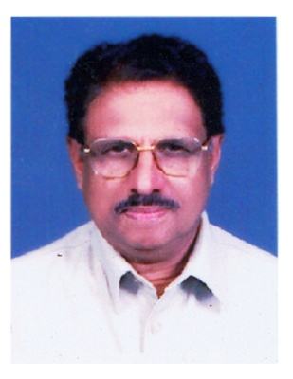  10.13 | Name of Teaching Staff | Prof. Dr. K. V. Kurien |  |  |  | PHOTO
1 | Designation | Director
 | Department | MCA
 | Date of Joining the Institution | 28/08/2006
 | Qualification with Class/Grade | UG |  | PG | Ph.D.
 |  | BSC PHYSICS |  | MSC  MBA(Exe) | MATERIAL SCIENCE
 | Total Experience in years | Teaching |  | Industry | Research
 |  | 21 |  | 14 | 25
 | Papers Published | National | International
 |  | 15 | 25
 | Ph.D. Guide? Give field & University | Field | University
 |  | Material Science | Kerala
 | Ph.D.s/ Projects Guide | PhDs | Projects at  Master Level
 |  | 2 | 10
 | Books Published/IPRs/Patents
 | Professional Memberships | Kerala Science Congress India National Science Congress, All India Crystal growth association
 | Consultancy Activities | Environment Consultant(KSTP)
 | Awards | Gold Medal for Best Researcher 1983, Kerala University
 | Grants fetched
 | Interaction with Professional Institutions | Rajeev Gandhi Institute of Bio Technology, Trivandrum  Centre for Resource Management as Development, Kerala Forest Research Institute Peechi,  Centre for Earth Science Studies, Trivandrum,  TBGRI, Trivandrum,  RRL, Trivandrum.

10.13 | Name of Teaching Staff | PROF. M. R. MOHANDAS |  |  |  | PHOTO  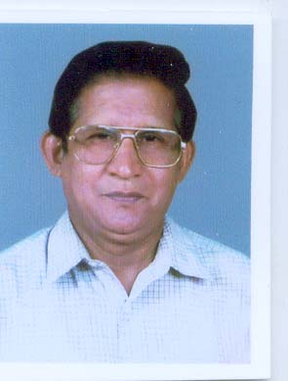
1 | Designation | PROFESSOR
 | Department | MCA
 | Date of Joining the Institution | 29.06.2005
 | Qualification with Class/Grade | UG |  | PG | Ph.D.
 |  | BCOM |  | MCOM
 | Total Experience in years | Teaching |  | Industry | Research
 |  | 41 |  | NIL | NIL
 | Papers Published | National | International
 |  | NIL | NIL
 | Ph.D. Guide? Give field & University | Field | University
 | Ph.D.s/ Projects Guide | PhDs | Projects at  Master Level
 | Books Published/IPRs/Patents
 | Professional Memberships
 | Consultancy Activities
 | Awards
 | Grants fetched
 | Interaction with Professional Institutions

10.13 | Name of Teaching Staff | PRIJI KURIAN ISAC |  |  |  | PHOTO  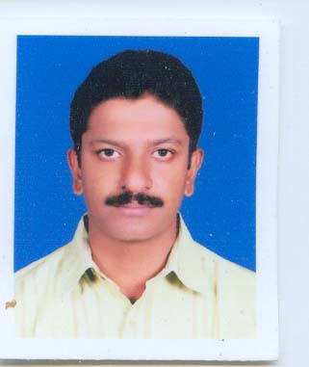
1 | Designation | HOD & ASST. PROFESSOR
 | Department | MCA
 | Date of Joining the Institution | 16.10.2002
 | Qualification with Class/Grade | UG |  | PG | Ph.D.
 |  | BSC CHEMISTRY  (2ND CLASS ) |  | MCA  (1ST CLASS)
 | Total Experience in years | Teaching |  | Industry | Research
 |  | 8 |  | 1 | NIL
 | Papers Published | National | International
 |  | NIL | NIL
 | Ph.D. Guide? Give field & University | Field | University
 | Ph.D.s/ Projects Guide | PhDs | Projects at  Master Level
 | Books Published/IPRs/Patents
 | Professional Memberships
 | Consultancy Activities
 | Awards
 | Grants fetched
 | Interaction with Professional Institutions

10.13 | Name of Teaching Staff | LINOY A THARAKAN |  |  | PHOTO  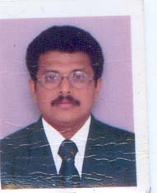
1 | Designation | ASST. PROFESSOR
 | Department | MCA
 | Date of Joining the Institution
 | Qualification with Class/Grade | UG |  | PG | Ph.D.
 |  | BSC ELECTRONICS |  | MSC ELECTRONICS | NIL
 | Total Experience in years | Teaching |  | Industry | Research
 |  | 6 |  | 2 | NIL
 | Papers Published | National | International
 |  | 6 | NIL
 | Ph.D. Guide? Give field & University | Field | University
 | Ph.D.s/ Projects Guide | PhDs | Projects at  Master Level
 | Books Published/IPRs/Patents
 | Professional Memberships
 | Consultancy Activities
 | Awards
 | Grants fetched
 | Interaction with Professional Institutions

10.13 | Name of Teaching Staff | SUSAMMA C.M |  |  | 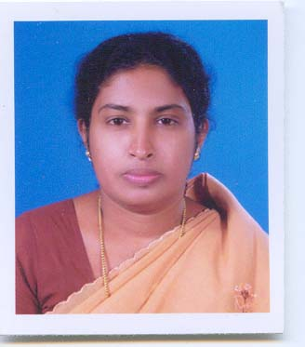  PHOTO
1 | Designation | ASSISTANT PROFESSOR
 | Department | MASTER OF COMPUTER APPLICATIONS
 | Date of Joining the Institution | 30/06/2005
 | Qualification with Class/Grade | UG |  | PG | Ph.D.
 |  | BSc(First class) |  | MSc(First class)
 | Total Experience in years | Teaching |  | Industry | Research
 |  | 16.5 yrs
 | Papers Published | National | International
 | Ph.D. Guide? Give field & University | Field | University
 | Ph.D.s/ Projects Guide | PhDs | Projects at  Master Level
 | Books Published/IPRs/Patents
 | Professional Memberships
 | Consultancy Activities
 | Awards
 | Grants fetched
 | Interaction with Professional Institutions

10.13 | Name of Teaching Staff | GIGI .M. MATHEW |  |  | 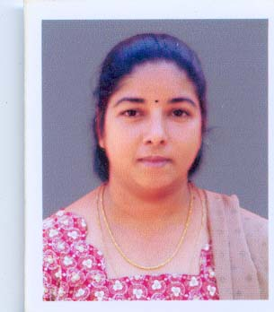  PHOTO
1 | Designation | LECTURER
 | Department | MASTER OF COMPUTER APPLICATIONS
 | Date of Joining the Institution | 01/07/2009
 | Qualification with Class/Grade | UG |  | PG | Ph.D.
 |  | BSc(First class) |  | MCA(First class)
 | Total Experience in years | Teaching |  | Industry | Research
 |  | 4 yrs |  | 3 yrs
 | Papers Published | National | International
 | Ph.D. Guide? Give field & University | Field | University
 | Ph.D.s/ Projects Guide | PhDs | Projects at  Master Level
 | Books Published/IPRs/Patents
 | Professional Memberships
 | Consultancy Activities
 | Awards
 | Grants fetched
 | Interaction with Professional Institutions

10.13 | Name of Teaching Staff | 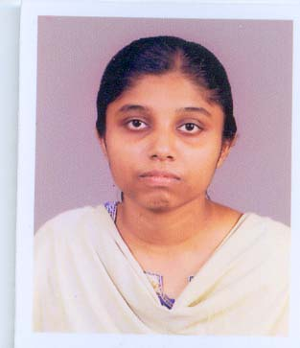  AGNES TEENA JOHN |  |  |  | PHOTO
1 | Designation | LECTURER
 | Department | MASTER OF COMPUTER APPLICATIONS
 | Date of Joining the Institution | 20/08/2007
 | Qualification with Class/Grade | UG |  | PG | Ph.D.
 |  | BSc(First class) |  | MCA(Distinction)
 | Total Experience in years | Teaching |  | Industry | Research
 |  | 3.5 yrs
 | Papers Published | National | International
 | Ph.D. Guide? Give field & University | Field | University
 | Ph.D.s/ Projects Guide | PhDs | Projects at  Master Level
 | Books Published/IPRs/Patents
 | Professional Memberships
 | Consultancy Activities
 | Awards
 | Grants fetched
 | Interaction with Professional Institutions

10.13 | Name of Teaching Staff | RETHY KUMARY.S |  |  |  | 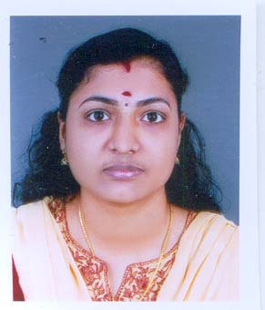  PHOTO
1 | Designation | LECTURER
 | Department | MASTER OF COMPUTER APPLICATIONS
 | Date of Joining the Institution | 02/01/2006
 | Qualification with Class/Grade | UG |  | PG | Ph.D.
 |  | BSc(First class) |  | MSc(First class)
 | Total Experience in years | Teaching |  | Industry | Research
 |  | 6 yrs
 | Papers Published | National | International
 | Ph.D. Guide? Give field & University | Field | University
 | Ph.D.s/ Projects Guide | PhDs | Projects at  Master Level
 | Books Published/IPRs/Patents
 | Professional Memberships
 | Consultancy Activities
 | Awards
 | Grants fetched
 | Interaction with Professional Institutions

10.13 | Name of Teaching Staff | 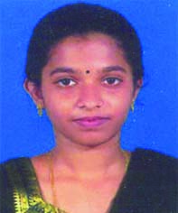  PRIJI PUNNOOSE |  |  |  | PHOTO
1 | Designation | LECTURER
 | Department | MASTER OF COMPUTER APPLICATIONS
 | Date of Joining the Institution | 09/06/2008
 | Qualification with Class/Grade | UG |  | PG | Ph.D.
 |  | BSc(First class) |  | MCA(Distinction)
 | Total Experience in years | Teaching |  | Industry | Research
 |  | 2.5 yrs
 | Papers Published | National | International
 | Ph.D. Guide? Give field & University | Field | University
 | Ph.D.s/ Projects Guide | PhDs | Projects at  Master Level
 | Books Published/IPRs/Patents
 | Professional Memberships
 | Consultancy Activities
 | Awards
 | Grants fetched
 | Interaction with Professional Institutions

10.13 | Name of Teaching Staff | 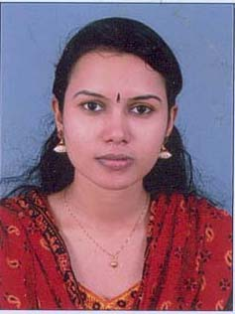  SARITHA S. S |  |  |  | PHOTO
1 | Designation | LECTURER
 | Department | MASTER OF COMPUTER APPLICATIONS
 | Date of Joining the Institution | 01/07/2009
 | Qualification with Class/Grade | UG |  | PG | Ph.D.
 |  | BSc(First class) |  | MCA(First class)
 | Total Experience in years | Teaching |  | Industry | Research
 |  | 2 yrs |  | 1 yr
 | Papers Published | National | International
 | Ph.D. Guide? Give field & University | Field | University
 | Ph.D.s/ Projects Guide | PhDs | Projects at  Master Level
 | Books Published/IPRs/Patents
 | Professional Memberships
 | Consultancy Activities
 | Awards
 | Grants fetched
 | Interaction with Professional Institutions

10.13 | Name of Teaching Staff | 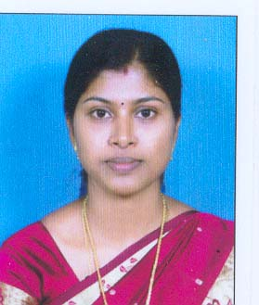  MARY GEENA .G |  |  |  | PHOTO
1 | Designation | LECTURER
 | Department | MASTER OF COMPUTER APPLICATIONS
 | Date of Joining the Institution | 06/12/2010
 | Qualification with Class/Grade | UG |  | PG | Ph.D.
 |  | BSc(First class) |  | MCA(First class)
 | Total Experience in years | Teaching |  | Industry | Research
 |  | 1 yr
 | Papers Published | National | International
 | Ph.D. Guide? Give field & University | Field | University
 | Ph.D.s/ Projects Guide | PhDs | Projects at  Master Level
 | Books Published/IPRs/Patents
 | Professional Memberships
 | Consultancy Activities
 | Awards
 | Grants fetched
 | Interaction with Professional Institutions

10.13 | Name of Teaching Staff | 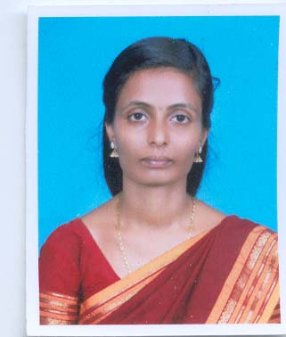  SOUMYA MANI |  |  |  | PHOTO
1 | Designation | LECTURER
 | Department | MASTER OF COMPUTER APPLICATIONS
 | Date of Joining the Institution | 16/06/2008
 | Qualification with Class/Grade | UG |  | PG | Ph.D.
 |  | BSc(First class) |  | MCA(Distinction)
 | Total Experience in years | Teaching |  | Industry | Research
 |  | 2.5 yrs
 | Papers Published | National | International
 | Ph.D. Guide? Give field & University | Field | University
 | Ph.D.s/ Projects Guide | PhDs | Projects at  Master Level
 | Books Published/IPRs/Patents
 | Professional Memberships
 | Consultancy Activities
 | Awards
 | Grants fetched
 | Interaction with Professional Institutions

10.13 | Name of Teaching Staff | 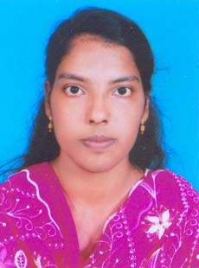  PRINCY THOMAS |  |  |  | PHOTO
1 | Designation | LECTURER
 | Department | MASTER OF COMPUTER APPLICATIONS
 | Date of Joining the Institution | 15/06/2009
 | Qualification with Class/Grade | UG |  | PG | Ph.D.
 |  | BSc(First class) |  | MCA(Distinction)
 | Total Experience in years | Teaching |  | Industry | Research
 |  | 1.5 yrs
 | Papers Published | National | International
 | Ph.D. Guide? Give field & University | Field | University
 | Ph.D.s/ Projects Guide | PhDs | Projects at  Master Level
 | Books Published/IPRs/Patents
 | Professional Memberships
 | Consultancy Activities
 | Awards
 | Grants fetched
 | Interaction with Professional Institutions

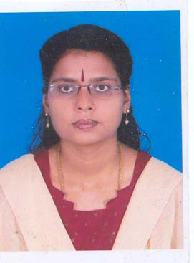  10.13 | Name of Teaching Staff | VRINDHA RAJAN |  |  |  | PHOTO
1 | Designation | ASSISTANT PROFESSOR(HOD)
 | Department | MASTER OF BUSINESS ADMINISTRATION
 | Date of Joining the Institution | 02/09/2010
 | Qualification with Class/Grade | UG |  | PG | Ph.D.
 |  | BA |  | MBA
 | Total Experience in years | Teaching |  | Industry | Research
 |  | 7 yrs |  | 1 yr | 6 months
 | Papers Published | National | International
 | Ph.D. Guide? Give field & University | Field | University
 | Ph.D.s/ Projects Guide | PhDs | Projects at  Master Level
 | Books Published/IPRs/Patents
 | Professional Memberships
 | Consultancy Activities
 | Awards
 | Grants fetched
 | Interaction with Professional Institutions

10.13 | Name of Teaching Staff | 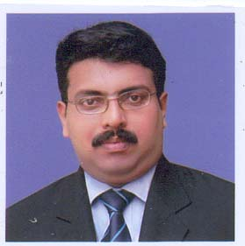  Dr. JOBI VARGHESE |  |  |  | PHOTO
1 | Designation | LECTURER
 | Department | MASTER OF BUSINESS ADMINISTRATION
 | Date of Joining the Institution | 02/09/2010
 | Qualification with Class/Grade | UG |  | PG | Ph.D.
 |  | BHMS |  | MBA
 | Total Experience in years | Teaching |  | Industry | Research
 |  | 6 months |  | 2 yrs
 | Papers Published | National | International
 | Ph.D. Guide? Give field & University | Field | University
 | Ph.D.s/ Projects Guide | PhDs | Projects at  Master Level
 | Books Published/IPRs/Patents
 | Professional Memberships
 | Consultancy Activities
 | Awards
 | Grants fetched
 | Interaction with Professional Institutions

10.13 | Name of Teaching Staff | 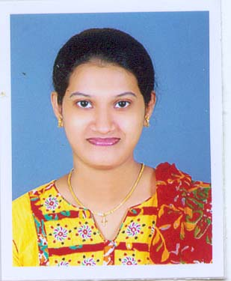  LINCY SAMUEL KALLUMKAL |  |  |  | PHOTO
1 | Designation | LECTURER
 | Department | MASTER OF BUSINESS ADMINISTRATION
 | Date of Joining the Institution | 07/09/2010
 | Qualification with Class/Grade | UG |  | PG | Ph.D.
 |  | Bsc Computer Science |  | MBA
 | Total Experience in years | Teaching |  | Industry | Research
 |  | 6 months |  | 2 yrs
 | Papers Published | National | International
 | Ph.D. Guide? Give field & University | Field | University
 | Ph.D.s/ Projects Guide | PhDs | Projects at  Master Level
 | Books Published/IPRs/Patents
 | Professional Memberships
 | Consultancy Activities
 | Awards
 | Grants fetched
 | Interaction with Professional Institutions

10.13 | Name of Teaching Staff | 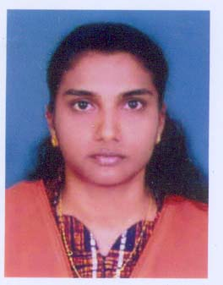  SURYA ROBERT |  |  |  | PHOTO
1 | Designation | LECTURER
 | Department | MASTER OF BUSINESS ADMINISTRATION
 | Date of Joining the Institution | 14/09/2010
 | Qualification with Class/Grade | UG |  | PG | Ph.D.
 |  |  |  | MBA(First Class)
 | Total Experience in years | Teaching |  | Industry | Research
 |  | 6 months |  | 1 yr
 | Papers Published | National | International
 | Ph.D. Guide? Give field & University | Field | University
 | Ph.D.s/ Projects Guide | PhDs | Projects at  Master Level
 | Books Published/IPRs/Patents
 | Professional Memberships
 | Consultancy Activities
 | Awards
 | Grants fetched
 | Interaction with Professional Institutions

10.13 | Name of Teaching Staff | Dr. R. Jubi |  | 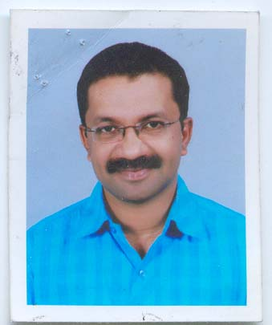
1 | Designation | PROFESSOR
 | Department | MASTER OF BUSINESS ADMINISTRATION
 | Date of Joining the Institution | 08/08/2011
 | Qualification with Class/Grade | UG | PG | Ph.D.
 |  | BTECH ECE | MBA(First Class) | BUSINESS ADMINISTRATION
 | Total Experience in years | Teaching | Industry | Research
 |  | 15 |  | 7
 | Papers Published | National | International
 |  | 4 | 4
 | Ph.D. Guide? Give field & University | Field | University
 |  | Management | Karpagam University, Asia e-University
 | Ph.D.s/ Projects Guide | PhDs | Projects at  Master Level
 |  | 2 | 5
 | Books Published/IPRs/Patents
 | Professional Memberships
 | Consultancy Activities
 | Awards
 | Grants fetched
 | Interaction with Professional Institutions

10.13 | Name of Teaching Staff | JITHIN RAJ |  |  | 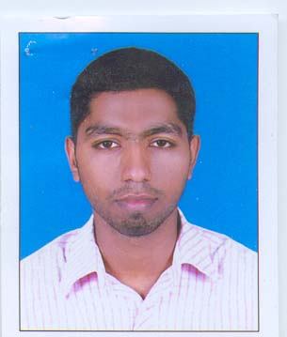
1 | Designation | LECTURER
 | Department | MASTER OF BUSINESS ADMINISTRATION
 | Date of Joining the Institution | 08/08/2011
 | Qualification with Class/Grade | UG |  | PG | Ph.D.
 |  | BCOM WITH COMPUTER APPLICATIONS |  | MBA | NIL
 | Total Experience in years | Teaching |  | Industry | Research
 |  | 0.6
 | Papers Published | National | International
 | Ph.D. Guide? Give field & University | Field | University
 | Ph.D.s/ Projects Guide | PhDs | Projects at  Master Level
 | Books Published/IPRs/Patents
 | Professional Memberships
 | Consultancy Activities
 | Awards
 | Grants fetched
 | Interaction with Professional Institutions

10.13 | Name of Teaching Staff | Elizabeth Jacob |  |  | 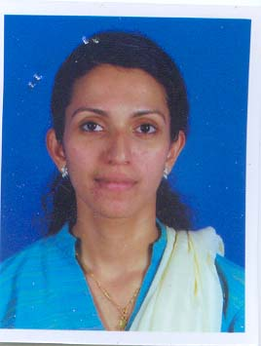
1 | Designation | Lecturer
 | Department | MASTER OF BUSINESS ADMINISTRATION
 | Date of Joining the Institution | 20/09/2011
 | Qualification with Class/Grade | UG |  | PG | Ph.D.
 |  | BBA |  | MBA
 | Total Experience in years | Teaching |  | Industry | Research
 |  | 3 |  | 1.5
 | Papers Published | National | International
 | Ph.D. Guide? Give field & University | Field | University
 | Ph.D.s/ Projects Guide | PhDs | Projects at  Master Level
 | Books Published/IPRs/Patents
 | Professional Memberships
 | Consultancy Activities
 | Awards
 | Grants fetched
 | Interaction with Professional Institutions

10.13 | Name of Teaching Staff | Aswathi Sathees |  |  | 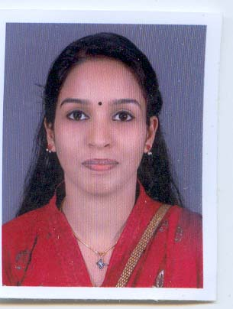
1 | Designation | Lecturer
 | Department | MASTER OF BUSINESS ADMINISTRATION
 | Date of Joining the Institution | 16/11/2011
 | Qualification with Class/Grade | UG |  | PG | Ph.D.
 |  | BCOM |  | MBA
 | Total Experience in years | Teaching |  | Industry | Research
 |  | .5 YEARS
 | Papers Published | National | International
 | Ph.D. Guide? Give field & University | Field | University
 | Ph.D.s/ Projects Guide | PhDs | Projects at  Master Level
 | Books Published/IPRs/Patents
 | Professional Memberships
 | Consultancy Activities
 | Awards
 | Grants fetched
 | Interaction with Professional Institutions

10.14 | Admission Quota | Merit / Management
 | Entrance test/Admission Criteria | CET Conducted the Commissioner for Entrance Examinations( Govt. of Kerala)
 | Cut off / last candidate admitted | 2011-12 2009-10 2008-09  50 % 50 % 60 %
 | Fees in Rupees | 2011-12 2010-11 2009-10  Rs 50, 000/- Rs 50, 000 Rs 50, 000/-
 | Number of Fee waivers offered | 2010-11 2009-10 2008-09  0 0 0
 | Admission Calendar | Last date for request for applications Last date for submission of application Release of admission list Starting of the academic session Last date for closing of admissions  01.09.2011 01.09.2011 02.09.2011 22.09.2011 30.10.2011
 | PIO quota | NO
 | Classroom/Tutorial Room facilities | 5 Classrooms of 104 Sqm area each(MCA)  4 Tutorial rooms of 52 Sqm area each(MCA)  5 Classrooms of 104 Sqm area each(MBA)  4 Tutorial rooms of 52 Sqm area each(MBA)
 | Laboratory details | 2 Laboratory of 300 Sqm area with 150 networked systems
 | Computer Centre facilities | 1Computer Centre (MCA Lab) with 60 networked systems.  1 Internet Lab with 30 networked systems
 | Library facilities | Volumes Titles Journals  National International  5925 1679 24 24
 | Auditorium / Seminar Halls / Amphi | Facility No Area in Sqm  Seminar hall 2 408
 | Cafeteria | YES
 | Indoor Sports facilities | YES
 | Outdoor Sports facilities | YES
 | Gymnasium facilities | NO
 | Facilities for disabled | NO
 | Any other facilities | TRANSPORTATION FACILITY  BACK UP POWER SUPPLY IS AVAILABLE
10.16 | Boys Hostel | YES
 | Girls Hostel | YES
 | Medical & other Facilities at Hostel | YES
10.17 | Academic Sessions | SEMESTER
 | Examination system, Year / Semester | SEMESTER
 | Period of declaration of results | 6
10.18 | Counseling/Monitoring | YES
 | Career Counseling | YES
 | Medical facilities | YES
 | Student Insurance | NO
10.19 | Students Activity Body | Students Welfare Association
 | Cultural activities | The college provides the opportunity to express their innate artistic talents. Arts Club is operating in the campus to conduct art festivals and other cultural events. We conducted art festival in performing arts and literary. Their performances were good, enchanting and scintillating.
 | Sports activities | The college has spacious grounds to play basket ball, cricket, shuttle-badminton, volleyball etc. The college provides facilities for indoor games, like caroms, chess, etc. The college conducts in-house competitions and games. Annual sport meet is conducted every year under the supervision of Sports Club
 | Literary activities | YES
 | Magazine / Newsletter | Zeal - Monthly Newsletter
 | Technical activities / Tech Fest | Yes , MCA association (BEST)
 | Industrial Visits / Tours | YES
 | Alumni activities | YES
10.20 | Name of the Information Officer for RTI | Prof. Dr. K. V. Kurien
 | Designation | Director
 | Phone number with STD code | 0474-2476535
 | FAX number with STD code | 0474-2477048
 | Email | miitayur@sancharnet.in

